Create Database and Tables

Step 1: create a new database school

**Query**: create database school

use school

step 2: creating student, class and subject tables in the school database

Queries:

create table student(

studid int primary key,

studname varchar(20),

studclass int

)

create table subject(

subid int primary key,

subname varchar(20))

create table class(

classno int primary key,

classname varchar(20) )

select*from student

select *from subject

select *from class

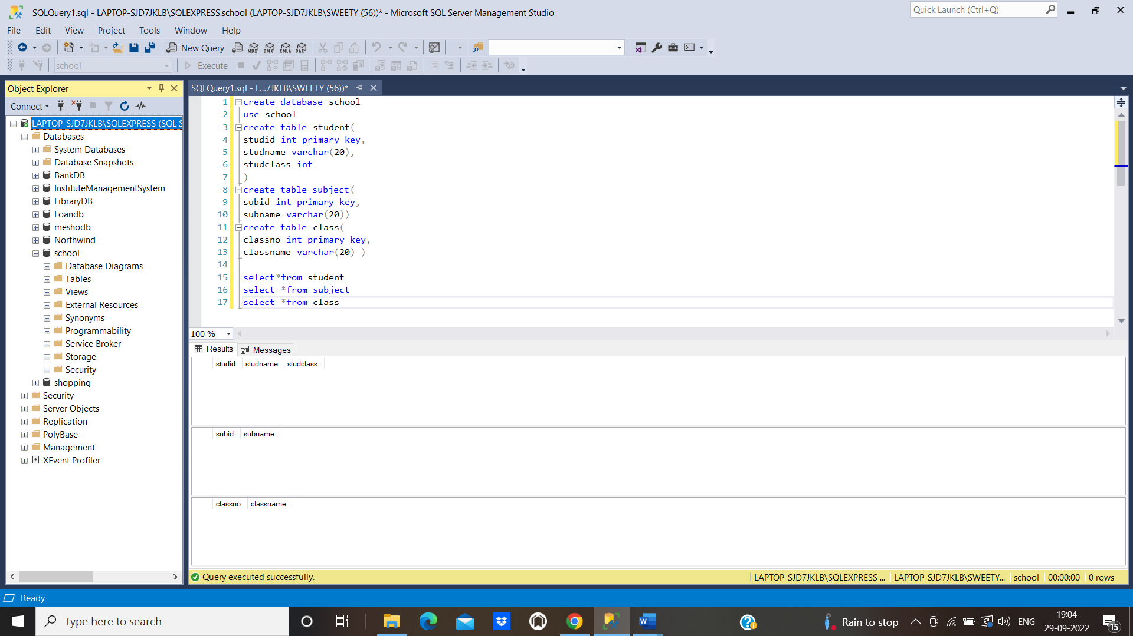

Step 3:

Push the code to your GitHub repository

* Open your command prompt and navigate to the folder where you have created your files.

**cd <folder path>**

* Initialize your repository using the following command:

**git init**

* Add all the files to your Git repository using the following command:

**git add .**

* Commit the changes using the following command:

**git commit . -m “Changes have been committed.”**

* Push the files to the folder you initially created using the following command:

**git push -u origin master**